Before you start writing
Before using the chapter templates, you will need to make a few changes in your Word Settings.
First Change
Go to Word Options | Proofing | AutoCorrect Options and do the following:
Within AutoCorrect Options, go to AutoFormat and uncheck the Internet and network paths with hyperlinks option.
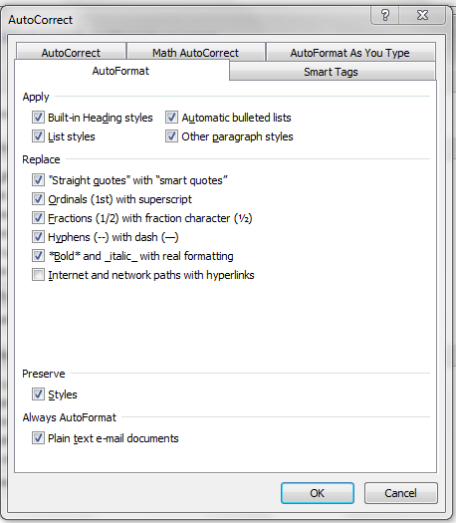
Within AutoCorrect Options, go to AutoFormat As You Type and uncheck the Internet and network paths with hyperlinks option.
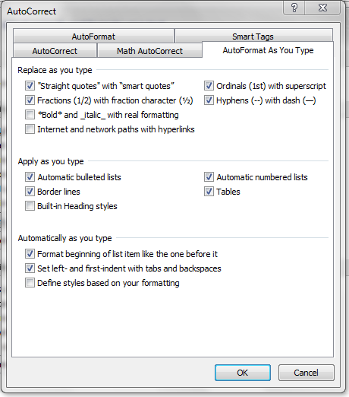
Second Change
Go to Styles | Options and do the following:
Under Select formatting to show as styles, uncheck the Paragraph level formatting, Font formatting and Bullet and numbering formatting.
Ensure that New documents based on this template option is selected.
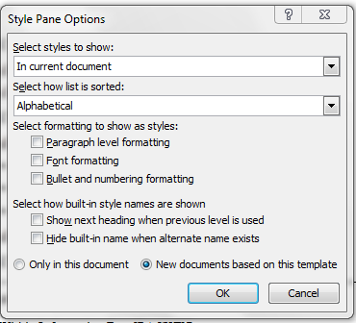
Please ensure that these changes are taken care of before you start writing.

